**Problem Statement: Pseudocode and Flowchart for Sorting Algorithm - Write pseudocode and create a flowchart for a bubble sort algorithm. Provide a brief explanation of how the algorithm works and a simple array of integers to demonstrate a dry run of your algorithm.**

**Solution:**

**Psuedo-Code for Bubble Sort Algorithm:**

**FUNCTION bubbleSort()**

**{**

**Read Array**

**FOR i=length of array to i >= 0:**

**{**

**FOR j=0 to j < i**

**{**

**IF Array[j] > Array[j+1]**

**{**

**Temp = Array[j]**

**Array[j] = Array[j+1]**

**Array[j+1] = temp**

**}**

**}**

**}**

**PRINT Array**

**}**

**Flow-Chart:**

**<https://lucid.app/lucidchart/48cace32-214a-47d5-ad47-593f75d30825/edit?viewport_loc=-452%2C380%2C3816%2C1812%2C0_0&invitationId=inv_2c7d0c43-a2dc-462f-941a-a57a4dc05c7d>**

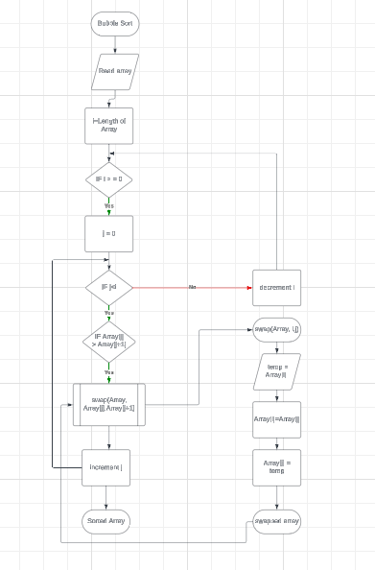

**How Algorithm Works:**

1. **From the above algorithm, the first loop runs from last index to first index.**
2. **Here integer i will be a pointer to determine upto which the j loop should run.**
3. **For i=last index the second loop will compare all the adjacent elements of array, if the element at j index is greater than element at j+1 index then the two elements will be swapped and this continues till the i pointer.**
4. **For every i iteration the highest element will be placed at where it should be from the last till the complete array is sorted.**
5. **Here we use i pointer because for every iteration the largest element will be at last position, and already it is largest of remaining array its waste of time to compare with them.**